Day32 - Task15 - AWS Auto-Scaling Groups

1.Create one VPC in N. Virginia region.
Create the VPC
- Review the configuration.
- Click Create VPC.
AWS will create the VPC in a few seconds.
Step 8: Verify the VPC
- Go back to Your VPCs.
- You should see:
  - Name: My-VPC
  - State: Available
  - CIDR: 10.0.0.0/16
  - Region: us-east-1
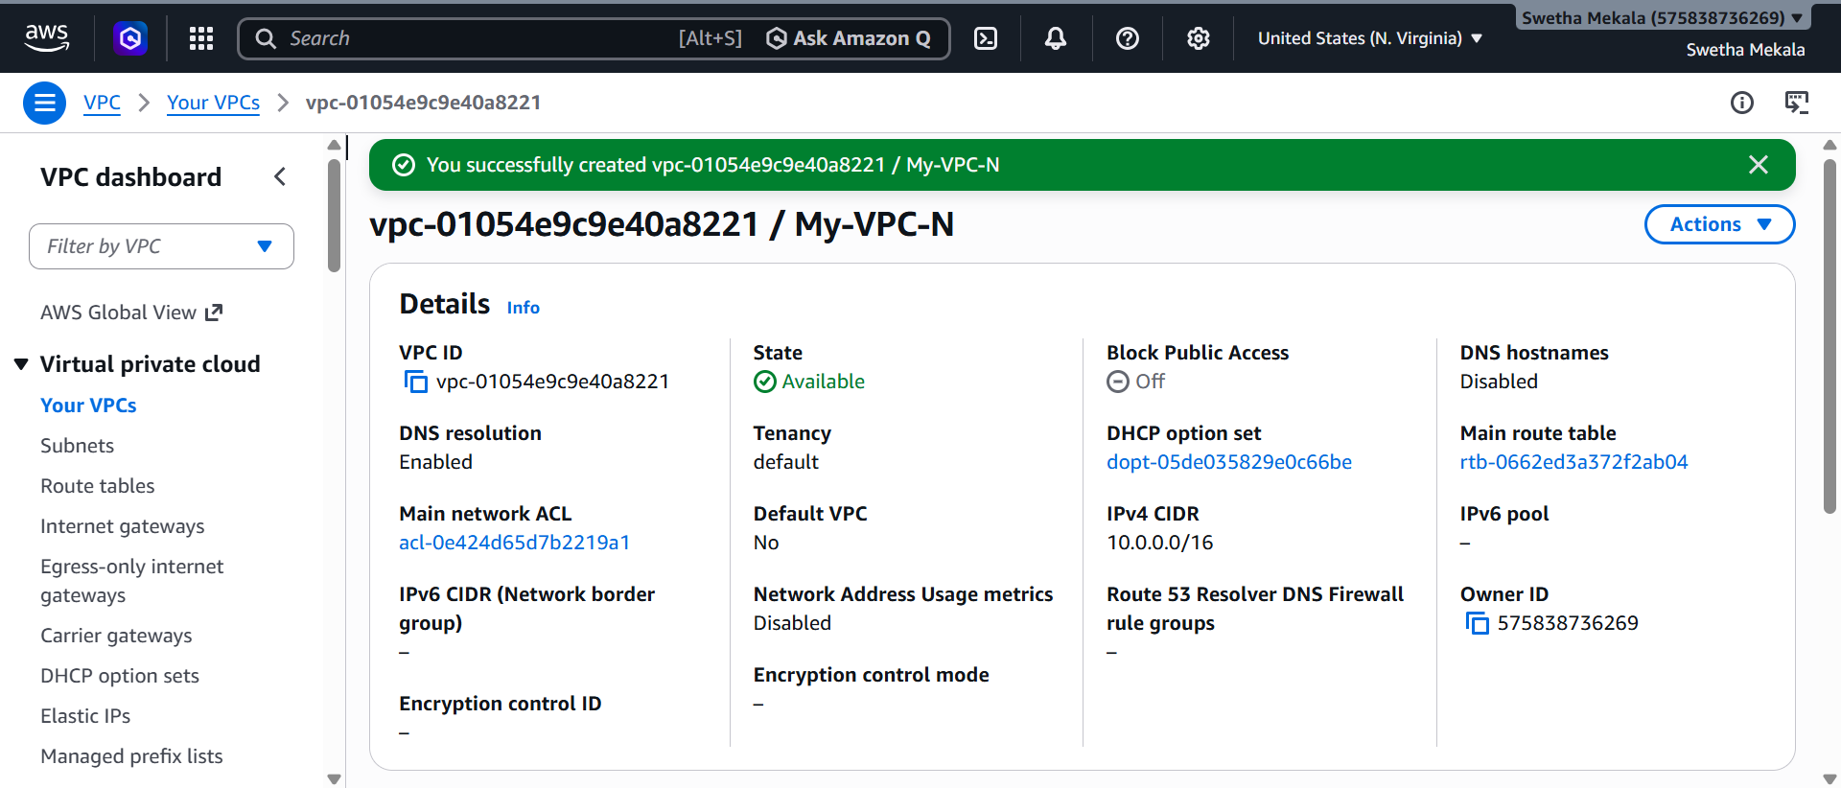
2.Create two subnets: one public subnet and one private subnet.
One Public Subnet
- Name: Public-Subnet
- CIDR: 10.0.1.0/24
- Availability Zone: us-east-1a
- Auto-assign public IPv4: Enabled

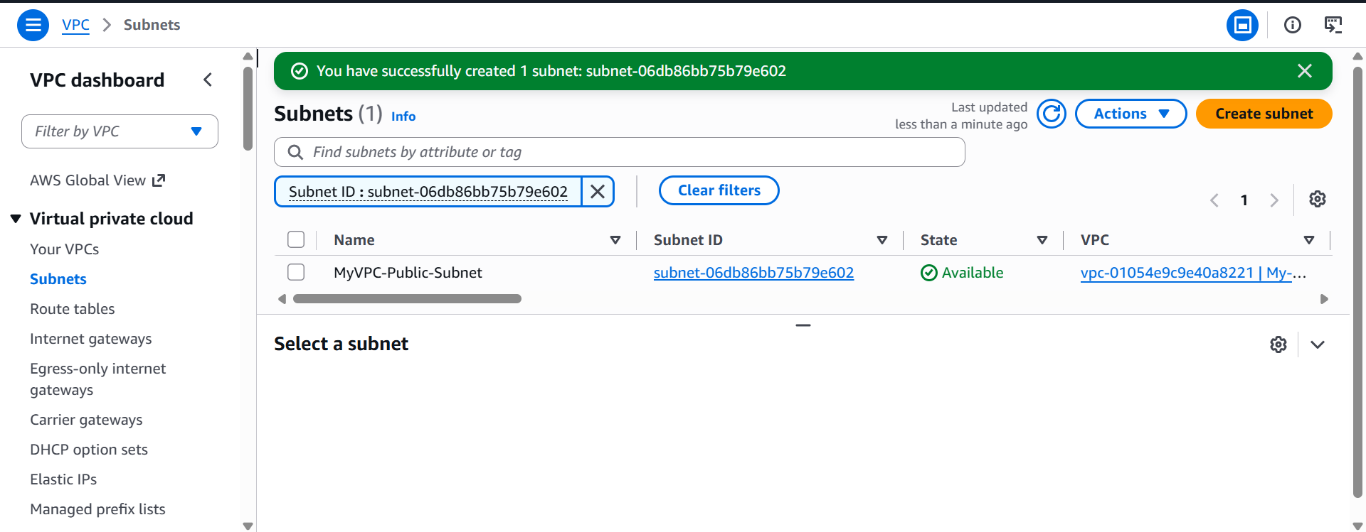
One Private Subnet
- Name: Private-Subnet
- CIDR: 10.0.2.0/24
- Availability Zone: us-east-1b
- Auto-assign public IPv4: Disabled
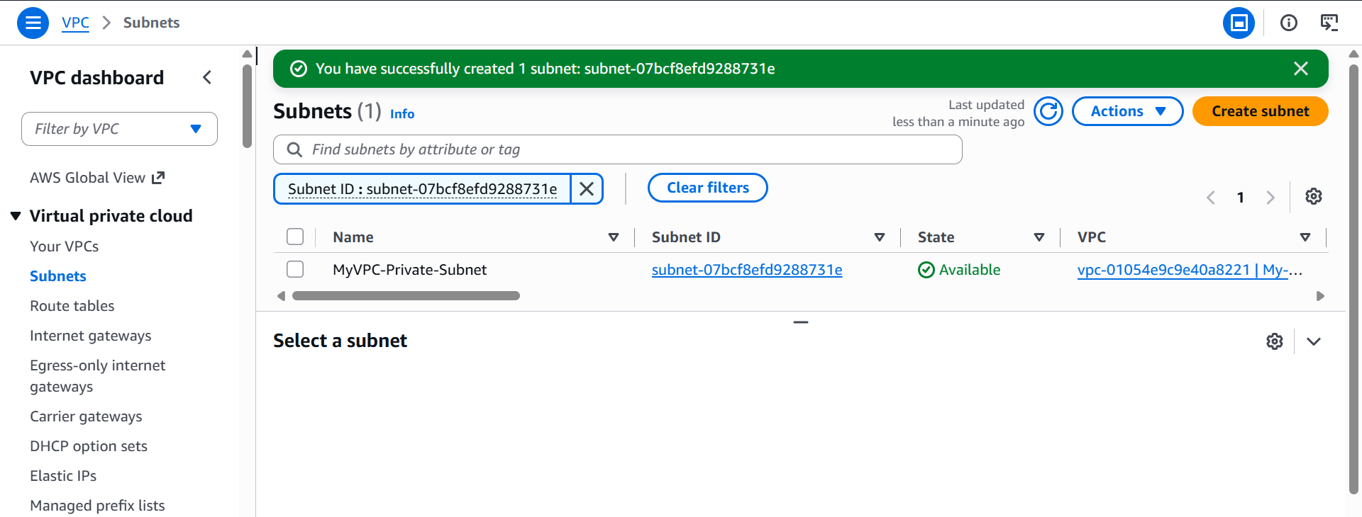
3.Attach an IGW to the VPC.
Go to Internet Gateways
- In the left navigation pane, under Virtual Private Cloud, click Internet Gateways.
- Click Create internet gateway.
Attach the Internet Gateway to Your VPC
- Select the newly created Internet Gateway (My-IGW).
- Click Actions.
- Select Attach to VPC.
- In the Available VPCs list, choose your VPC (for example, My-VPC).
- Click Attach internet gateway.
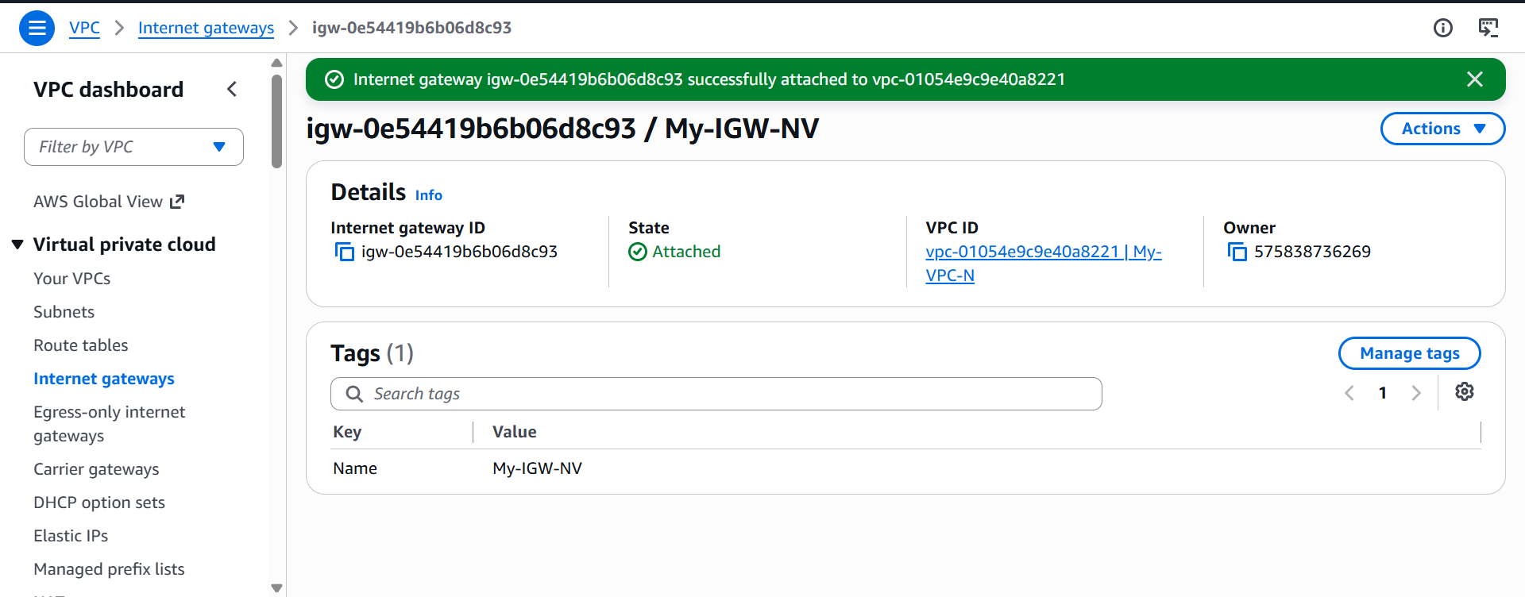
Create one public route table (RT) and one private route table.
Go to Route Tables
- In the left navigation pane, click Route Tables.
- Click Create route table.
Create the Public Route Table
Enter the following details:
Field | Value
Name | Public-RT
VPC | My-VPC
- Enter Public-RT as the name.
- Select My-VPC.
- Click Create route table.
The public route table is now created.

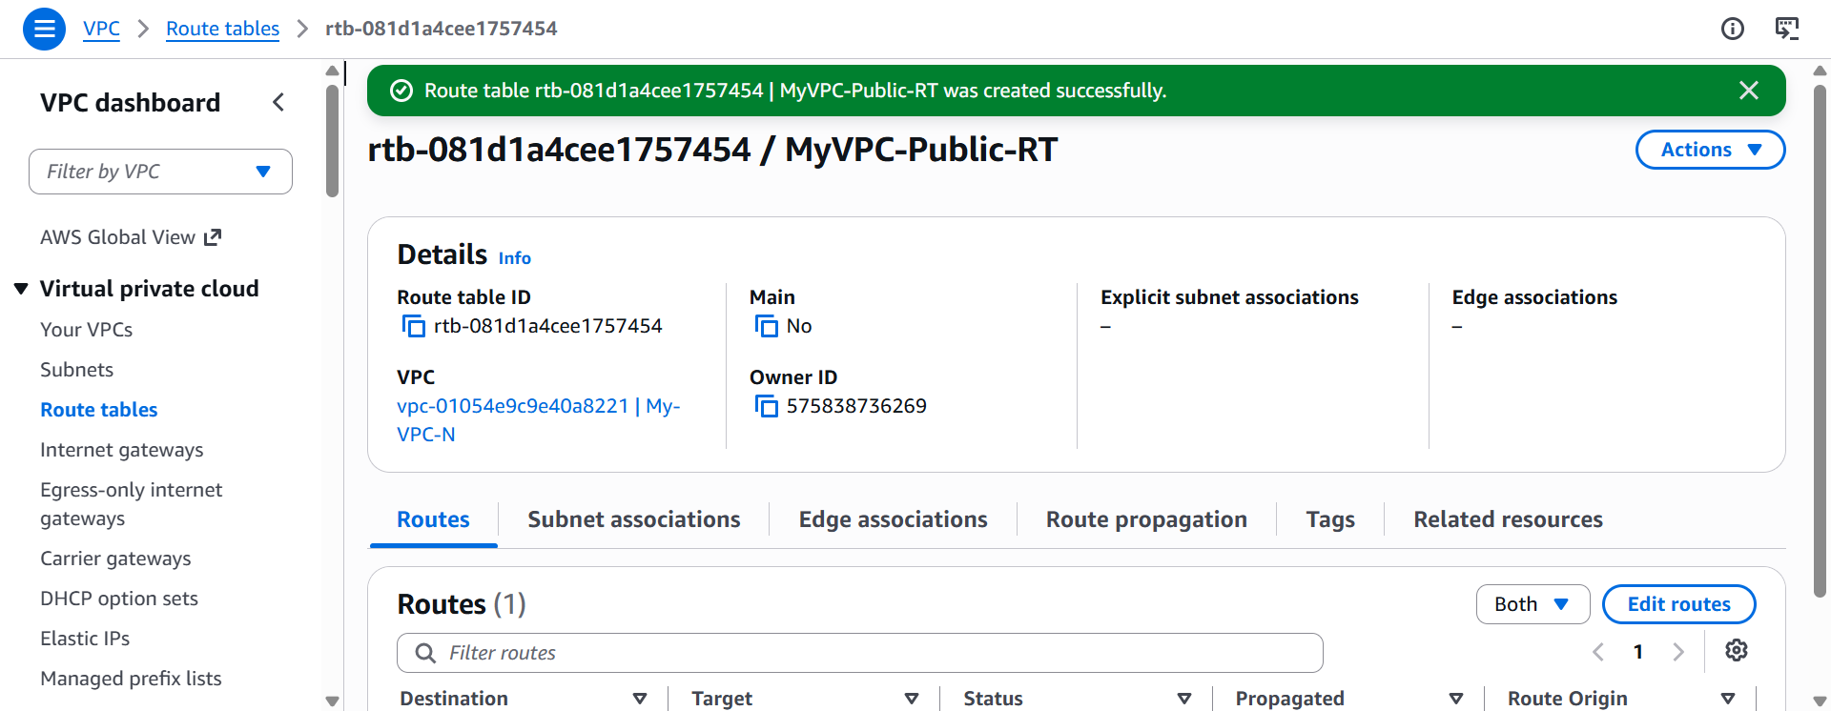
Create the Public Route Table
Enter the following details:
Field | Value
Name | Public-RT
VPC | My-VPC
- Enter Public-RT as the name.
- Select My-VPC.
- Click Create route table.
The public route table is now created.
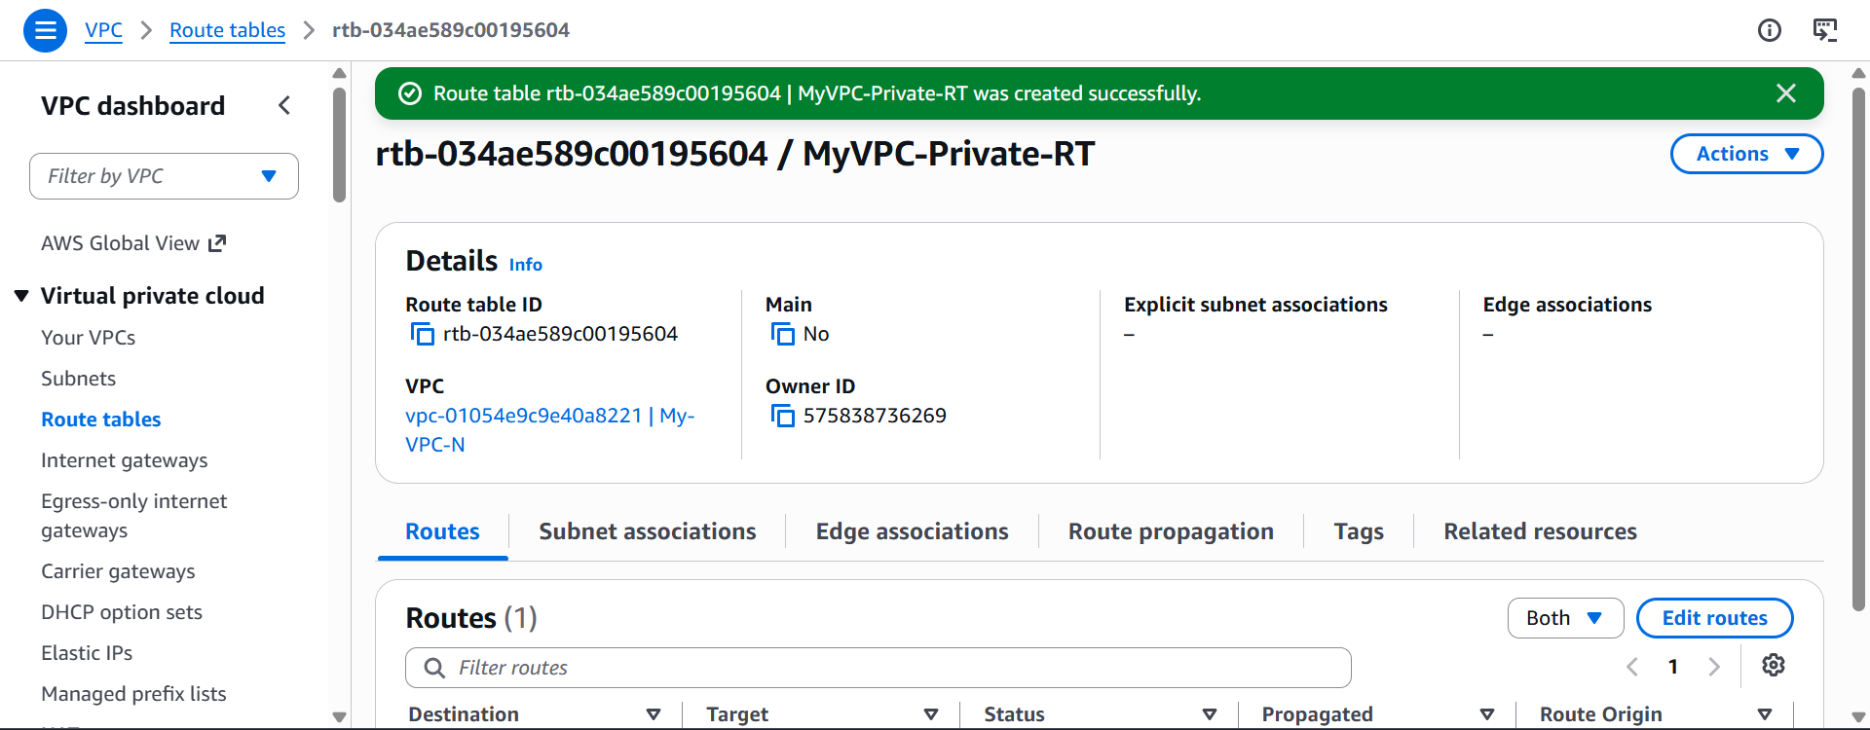
Deploy a NAT gateway in the public subnet and attach the NAT gateway to the private subnet.
Allocate an Elastic IP (EIP)
A NAT Gateway requires an Elastic IP (a static public IPv4 address).
- Sign in to the AWS Management Console.
- Select the US East (N. Virginia) - us-east-1 region.
- In the search bar, type VPC and open the VPC Dashboard.
- In the left navigation pane, click Elastic IPs.
- Click Allocate Elastic IP address.
- Leave the default settings.
- Click Allocate.
You will now have an Elastic IP that can be assigned to the NAT Gateway.
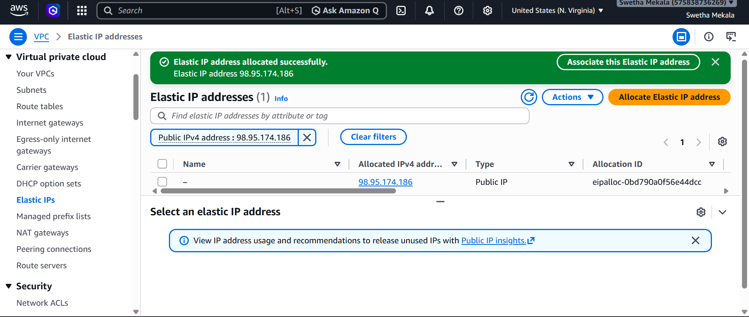
Create the NAT Gateway
- In the left navigation pane, click NAT Gateways.
- Click Create NAT Gateway.
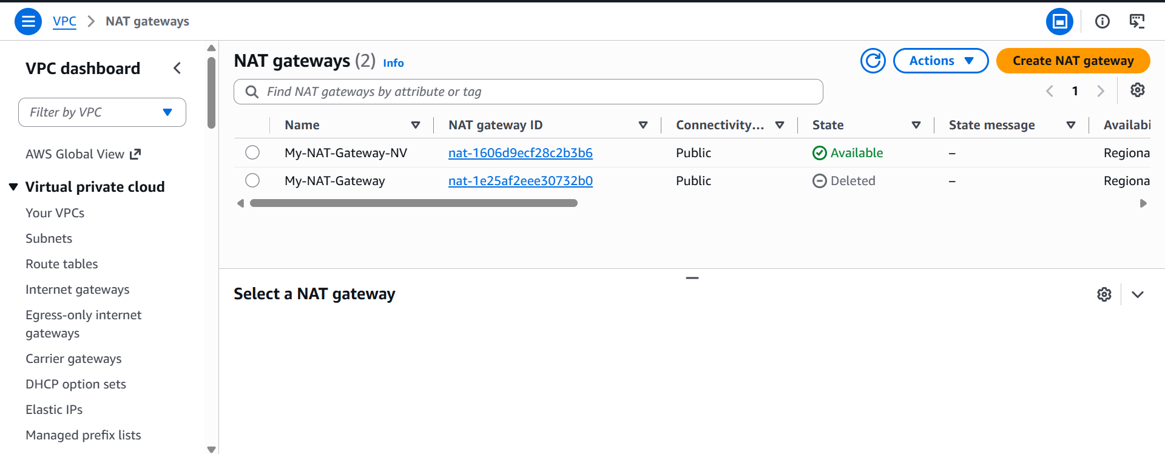
Associate the Private Route Table with the Private Subnet
If you have not already associated the route table:
- Select Private-RT.
- Open the Subnet Associations tab.
- Click Edit subnet associations.
- Select Private-Subnet.
- Click Save associations.

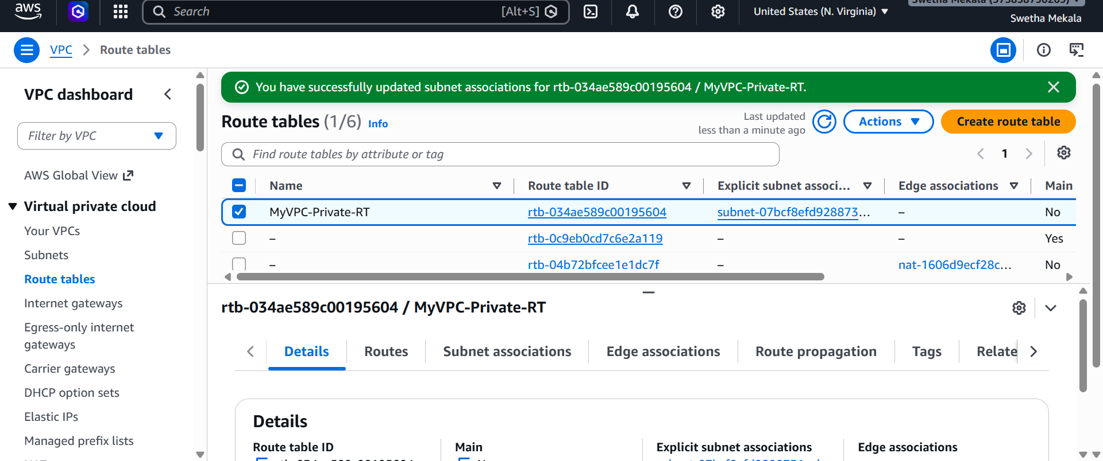
Update the Private Route Table
Now configure the private subnet to send internet-bound traffic through the NAT Gateway.
- In the left navigation pane, click Route Tables.
- Select Private-RT.
- Open the Routes tab.
- Click Edit routes.
- Click Add route.
Enter:
Destination | Target
0.0.0.0/0 | NAT Gateway → My-NAT-Gateway
- Click Save changes.
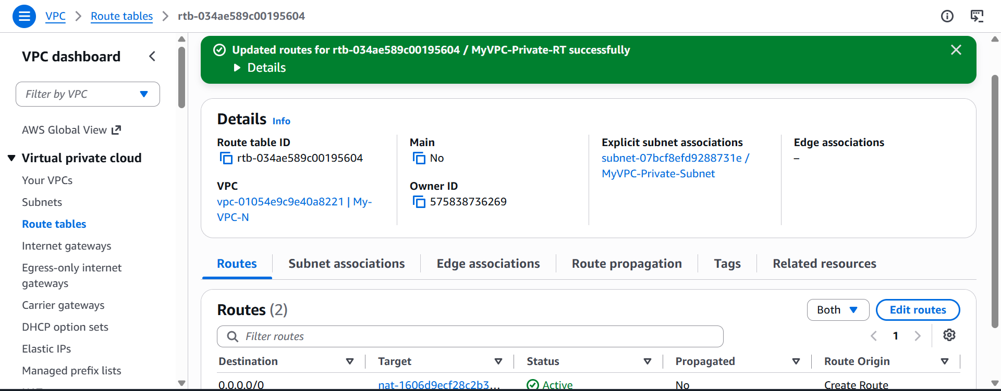
Create two instances, one in the public subnet and one in the private subnet.
Public EC2 Instance
Instance Details
Setting | Value
Name | Public-EC2
AMI | Amazon Linux 2023
Instance Type | t2.micro (or t3.micro)
Key Pair | Your existing key pair
Security Group
Create a new security group (for example, Public-EC2-SG) with these inbound rules:
Type | Port | Source
SSH | 22 | My IP (recommended) or 0.0.0.0/0 for a lab
HTTP | 80 | 0.0.0.0/0
Custom TCP | 8080 | 0.0.0.0/0 (only if your application uses port 8080)

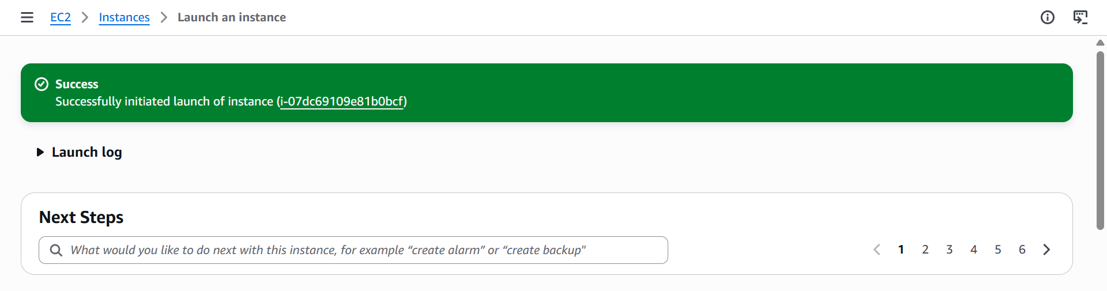
Private EC2 Instance
Instance Details
Setting | Value
Name | Private-EC2
AMI | Amazon Linux 2023
Instance Type | t2.micro (or t3.micro)
Key Pair | Same key pair
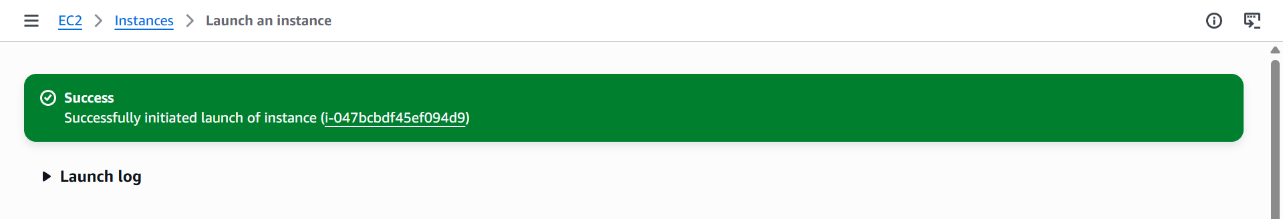
Deploy Apache server on both EC2 instances with a sample index.html file.
Connect to the Public EC2 Instance
From your local machine, run:
ssh -I NorthVirginiaKey.pem ec2-user@98.86.181.103
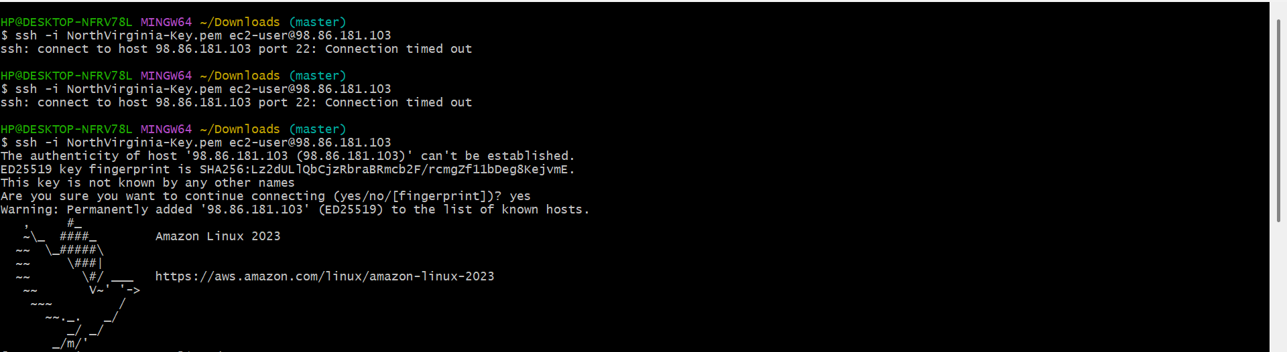
Install Apache on the Public EC2
For Amazon Linux 2023:
sudo dnf update -y
sudo dnf install -y httpd
Start and Enable Apache
Start the Apache service:
sudo systemctl start httpd
Enable it to start automatically on boot:
sudo systemctl enable httpd
Check its status:
sudo systemctl status httpd
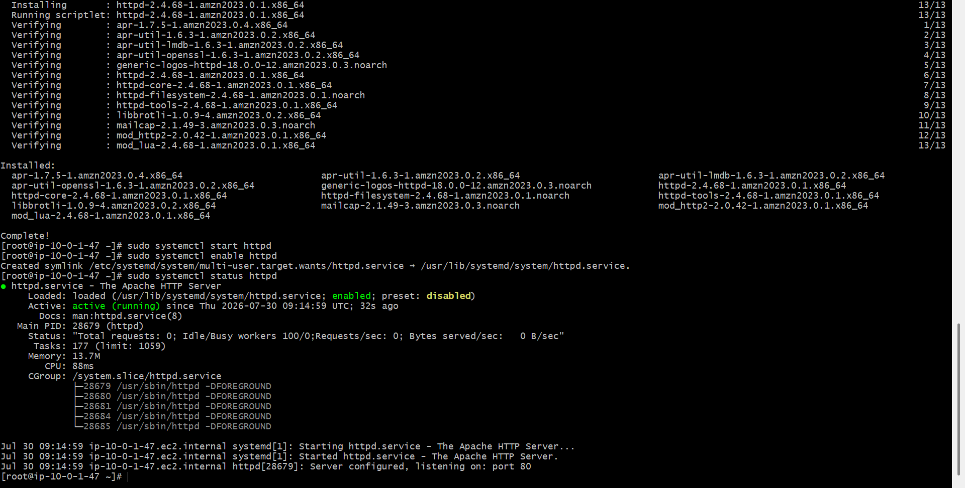
Create a Sample index.html
Create a simple web page:
echo "<h1>Welcome to Public EC2 Apache Server</h1>" | sudo tee /var/www/html/index.html
Verify the file:
cat /var/www/html/index.html
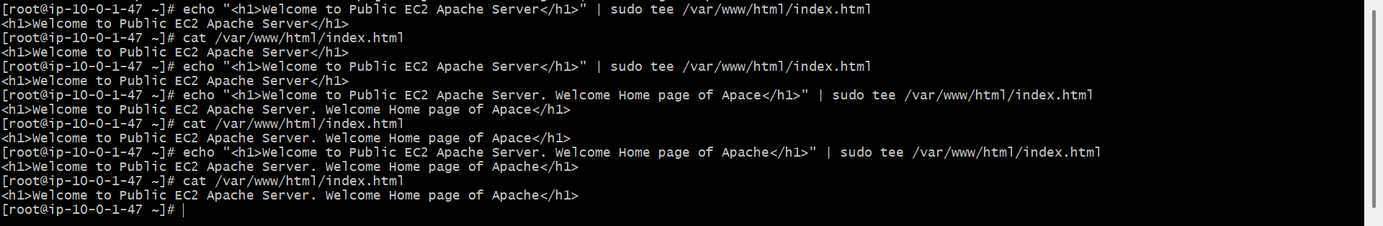
Test the Public Web Server
Open a web browser and enter:
http:// 98.86.181.103
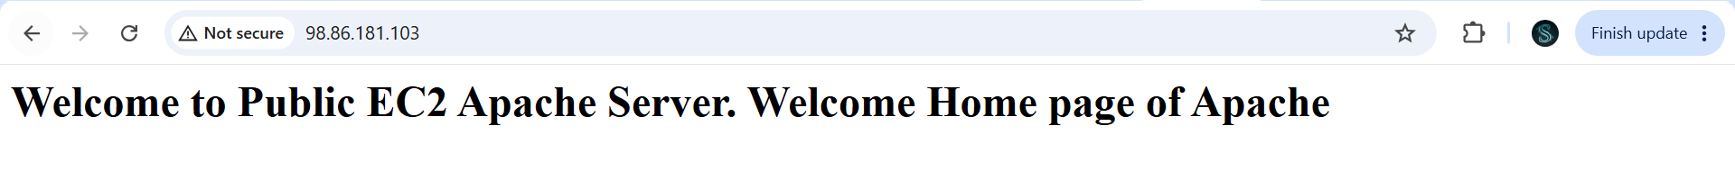
Connect to the Public EC2 from your laptop
From Git Bash on your laptop:
ssh -i NorthVirginia-Key.pem ec2-user@<Public-EC2-Public-IP>
Copy the .pem file to the Public EC2
scp -i NorthVirginia-Key.pem NorthVirginia-Key.pem ec2-user@98.86.181.103:/home/ec2-user/
This copies your key file from the laptop to the Public EC2.
Then SSH back into the Public EC2:
ssh -i NorthVirginia-Key.pem ec2-user@98.86.181.103
Verify the key is there:
ls
You should see:
NorthVirginia-Key.pem
Set the correct permissions:
chmod 400 NorthVirginia-Key.pem
Connect from the Public EC2 to the Private EC2
Now use the Private EC2's private IP:
ssh -i NorthVirginia-Key.pem ec2-user@10.0.2.215

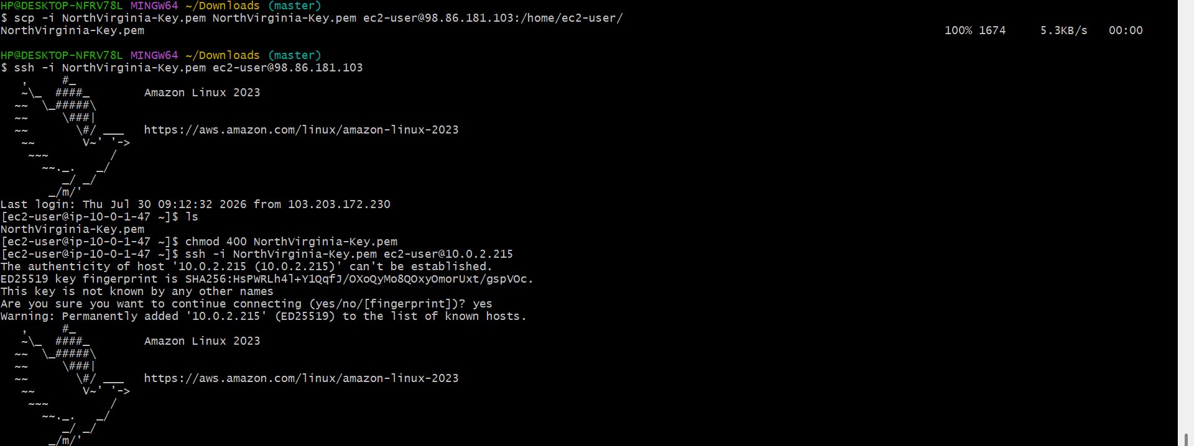
Install Apache on the Private EC2
Run:
sudo dnf update -y
sudo dnf install -y httpd
sudo systemctl start httpd
sudo systemctl enable httpd
sudo systemctl status httpd
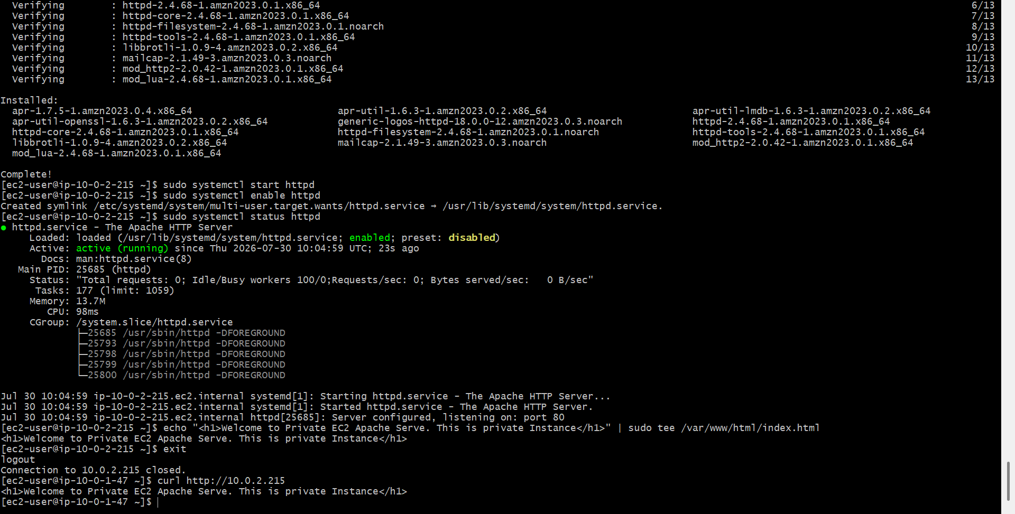
Create a sample web page
echo "<h1>Welcome to Private EC2 Apache Server</h1>" | sudo tee /var/www/html/index.html
Verify it:
cat /var/www/html/index.html
Test the Private EC2
Exit back to the Public EC2:
exit
Now, from the Public EC2, run:
curl http://10.0.2.215
If everything is configured correctly, you'll see:
<h1>Welcome to Private EC2 Apache Server</h1>
Create one application load balancer and attach it to both EC2 instances.
Create a Second Public Subnet
Select your VPC (My-VPC-N).
Enter:
- Subnet Name: MyVPC-Public-Subnet-2
- Availability Zone: us-east-1b
- IPv4 CIDR: 10.0.3.0/24
Click Create subnet.
Enable Auto-assign Public IPv4 for the new subnet.
Associate the new subnet with your existing Public Route Table.
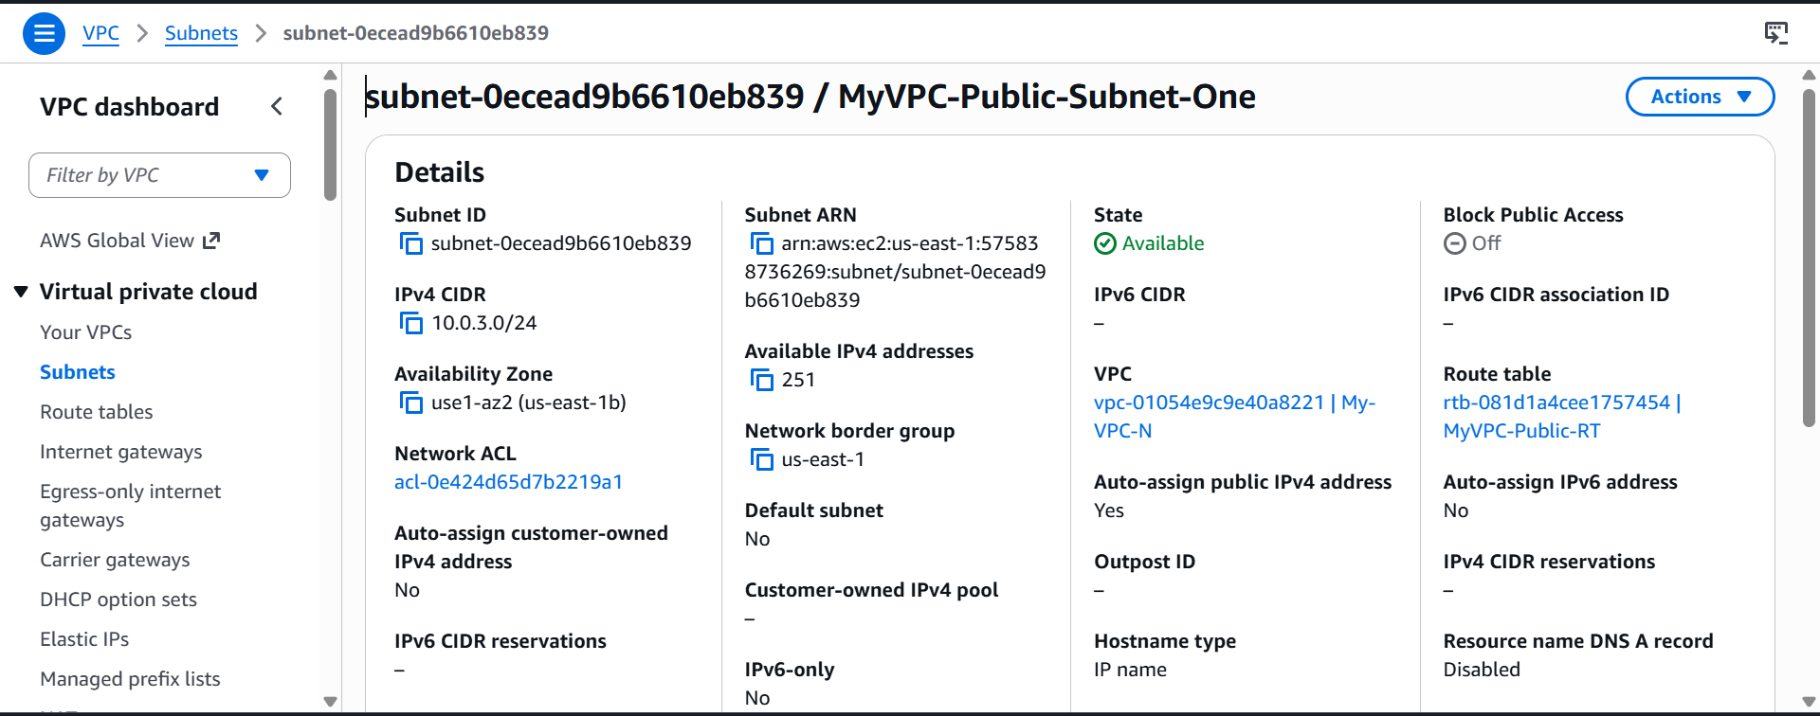
Create the Application Load Balancer
Create Load Balancer.
Select Application Load Balancer.
Click Create
Configure the ALB
Enter the following:
Setting | Value
Load Balancer Name | My-ALB
Scheme | Internet-facing
IP Address Type | IPv4
VPC | My-VPC-N
Leave Use IPAM pool unchecked.
Select the Public Subnets
Under Network Mapping:
Select:
- ✅ Public Subnet (us-east-1a)
- ✅ Public Subnet (us-east-1b)
Do not select the private subnet. Internet-facing ALBs are placed only in public subnets.
Create a Security Group for the ALB
Create a new Security Group.
Example:
- Name: ALB-SecurityGroup
Inbound Rules
Type | Port | Source
HTTP | 80 | 0.0.0.0/0
Outbound Rules
Type | Destination
All Traffic | 0.0.0.0/0
Click Create Security Group.
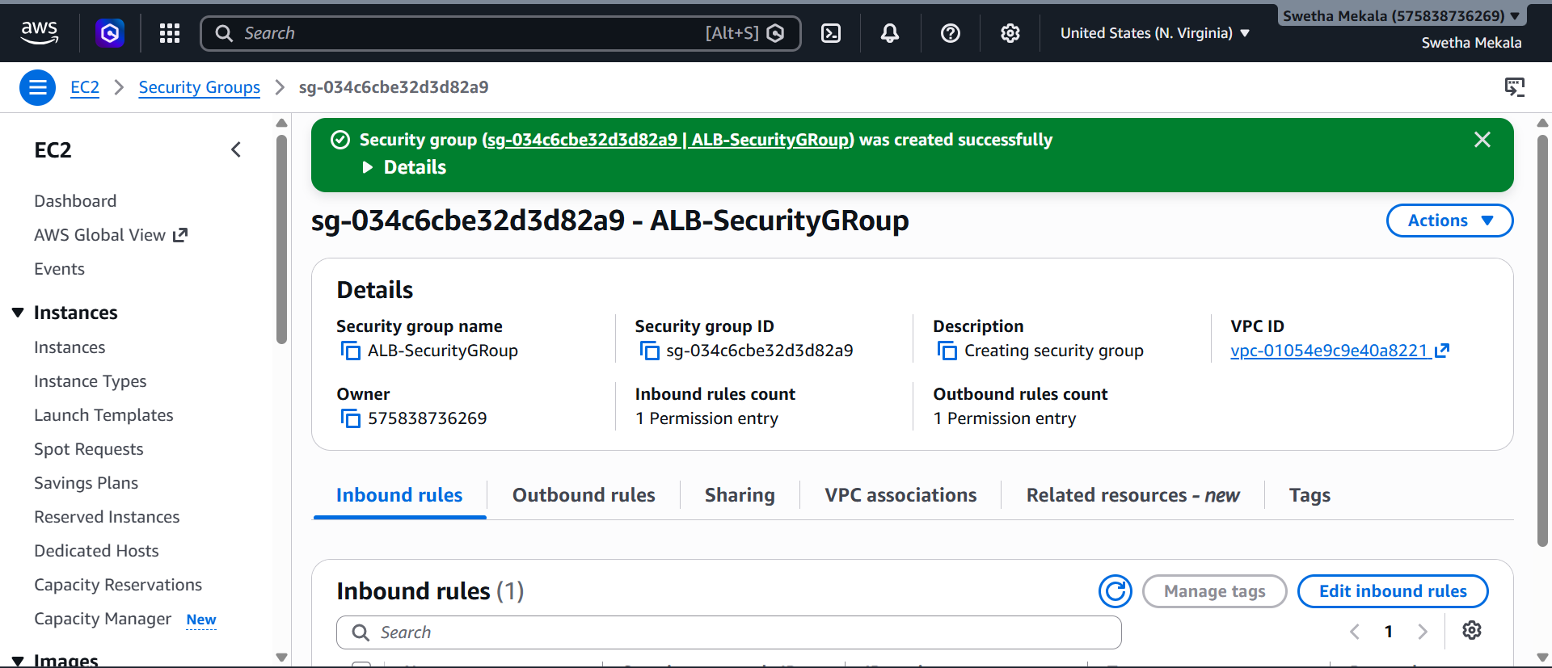
Create a Target Group
Click Create Target Group.
Enter:
Setting | Value
Target Type | Instances
Target Group Name | My-Target-Group
Protocol | HTTP
Port | 80
IP Address Type | IPv4
VPC | My-VPC-N
Protocol Version | HTTP1
Health Check Protocol | HTTP
Health Check Path | /
Leave the remaining settings as default.
Click Next.
Register the EC2 Instances
Select both EC2 instances:
- ✅ NV-Public-EC2
- ✅ NV-Private-EC2
Keep the port as:
80
Click:
Include as pending below
Verify both instances appear under Targets.
Click Create Target Group.
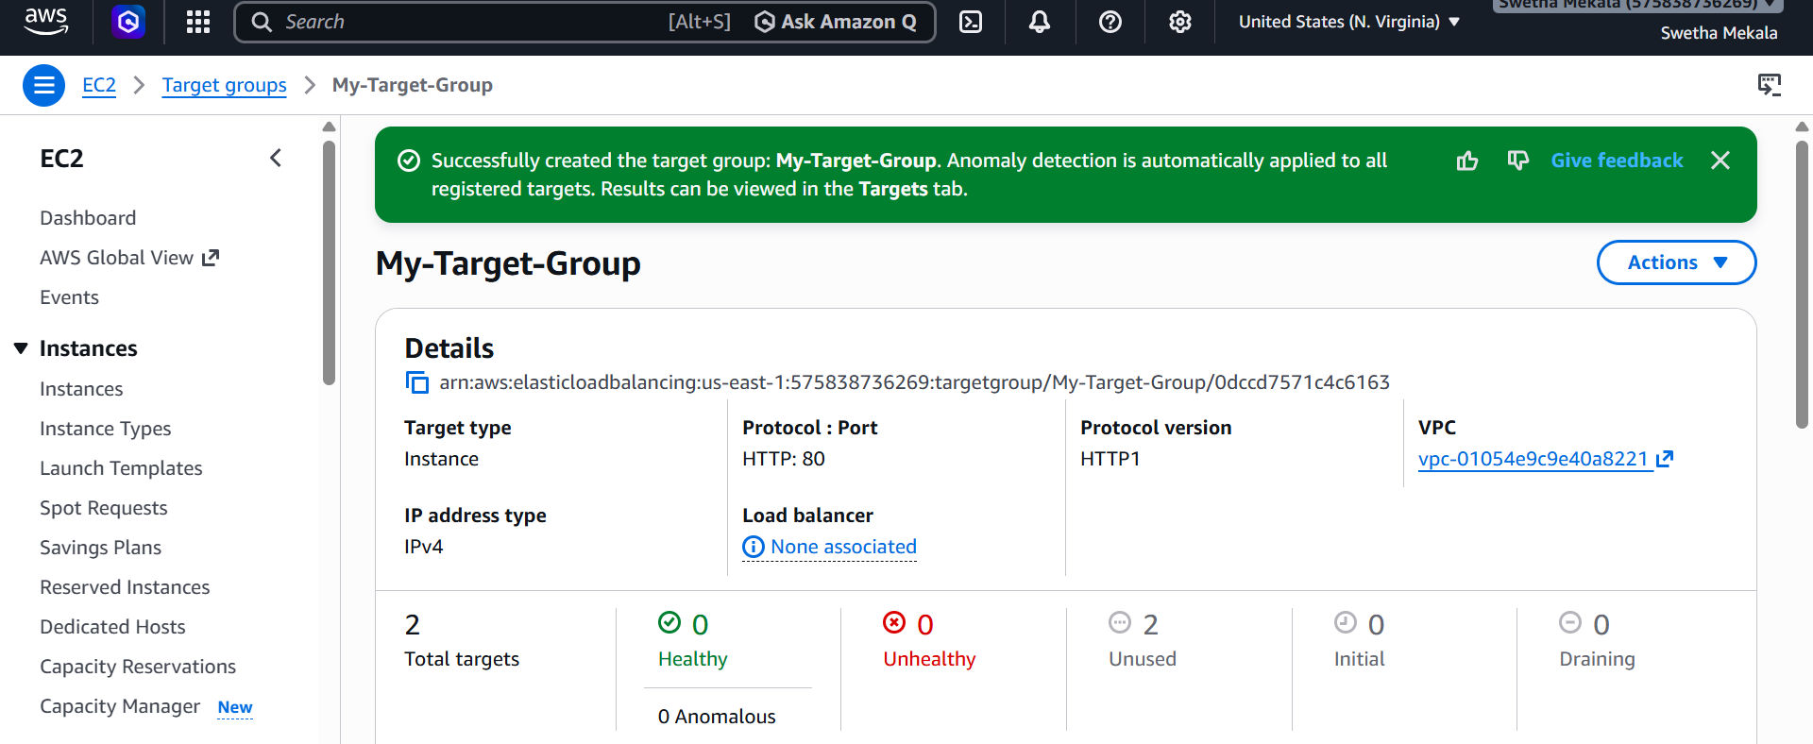
Attach the Target Group to the ALB
Return to the Create Load Balancer page.
Under Default Action:
- Routing Action: Forward to Target Groups
- Target Group: My-Target-Group
- Weight: 1 (100%)
- Target Group Stickiness: Leave Off
Click Create Load Balancer.

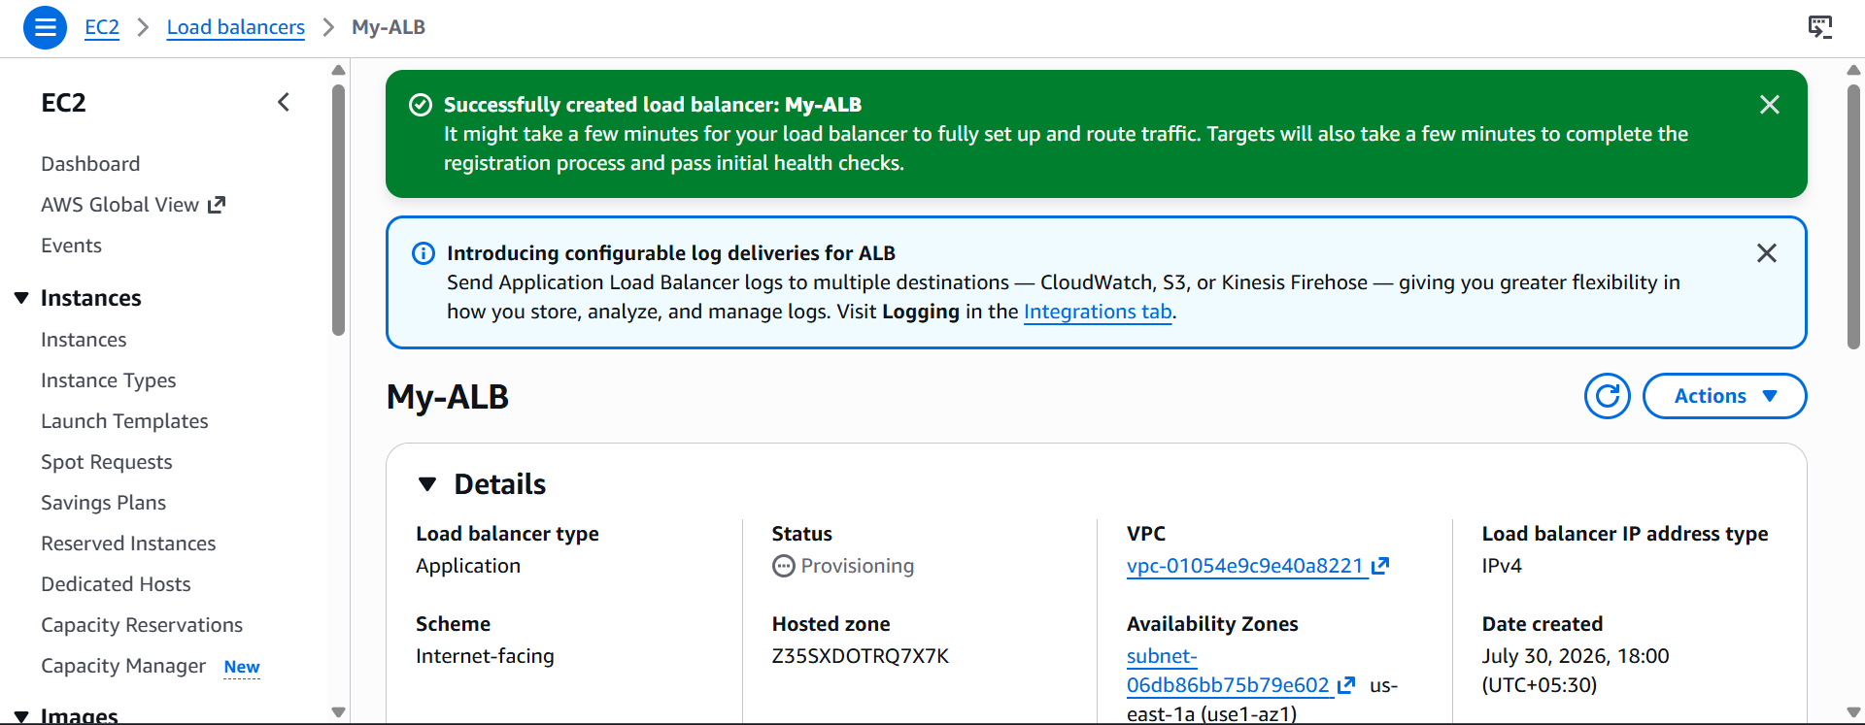
Verify the Target Group
Go to:
EC2 → Target Groups → My-Target-Group → Targets
Verify:
Instance | Health Status
NV-Public-EC2 | Healthy
NV-Private-EC2 | Healthy
If both are Healthy, the ALB is correctly routing traffic.
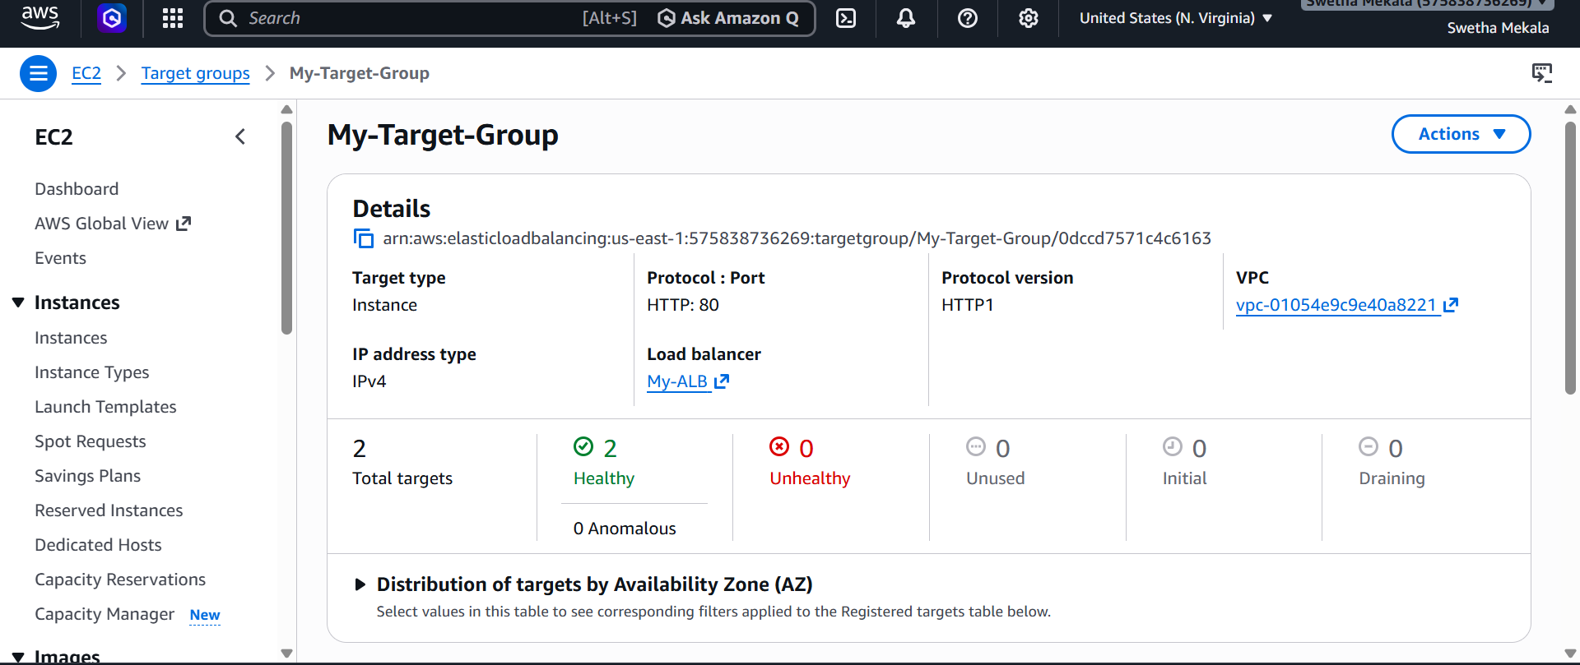
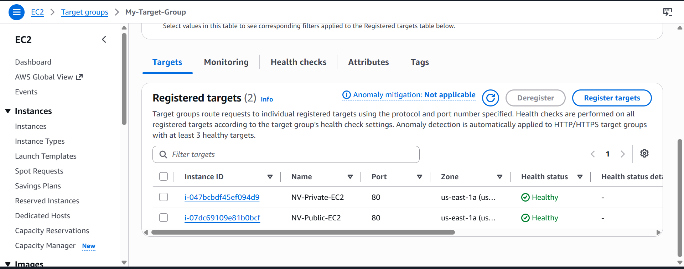
Test the ALB
- Open EC2 → Load Balancers.
- Select My-ALB.
- Copy the DNS Name.
- Open it in a web browser: http:My-ALB-1835912142.us-east-1.elb.amazonaws.com

Store application load balancer logs in S3.
Create an S3 Bucket
Click Create bucket.
Region: US East (N. Virginia) - us-east-1 (same region as your ALB).
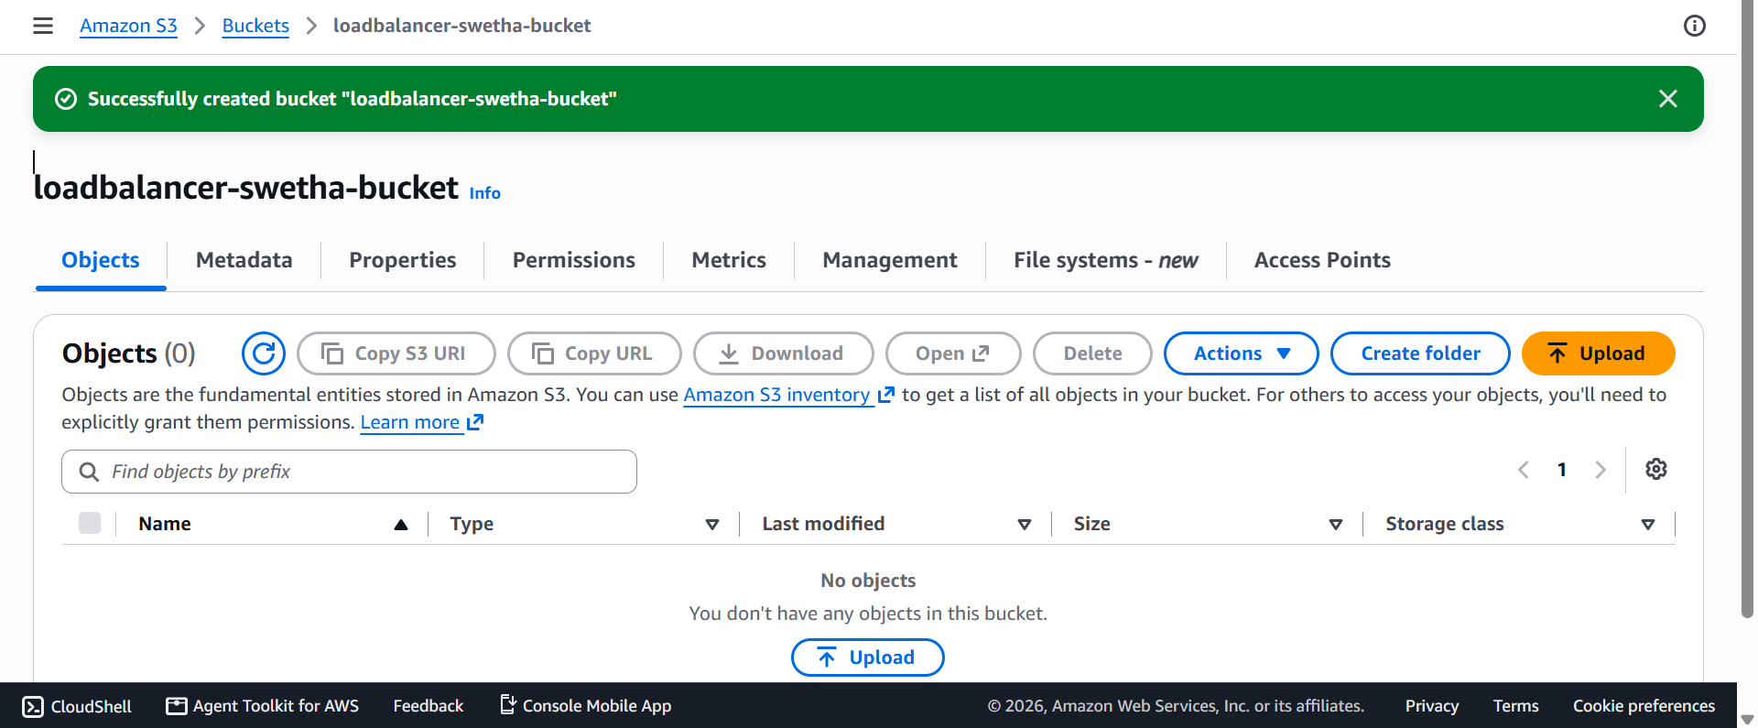
Add a Bucket Policy
Go to the Permissions tab.
Under Bucket Policy, click Edit.
Replace <YOUR_BUCKET_NAME> with your bucket name.
Replace <ACCOUNT_ID> with your AWS Account ID (your screenshots show it as 575838736269).

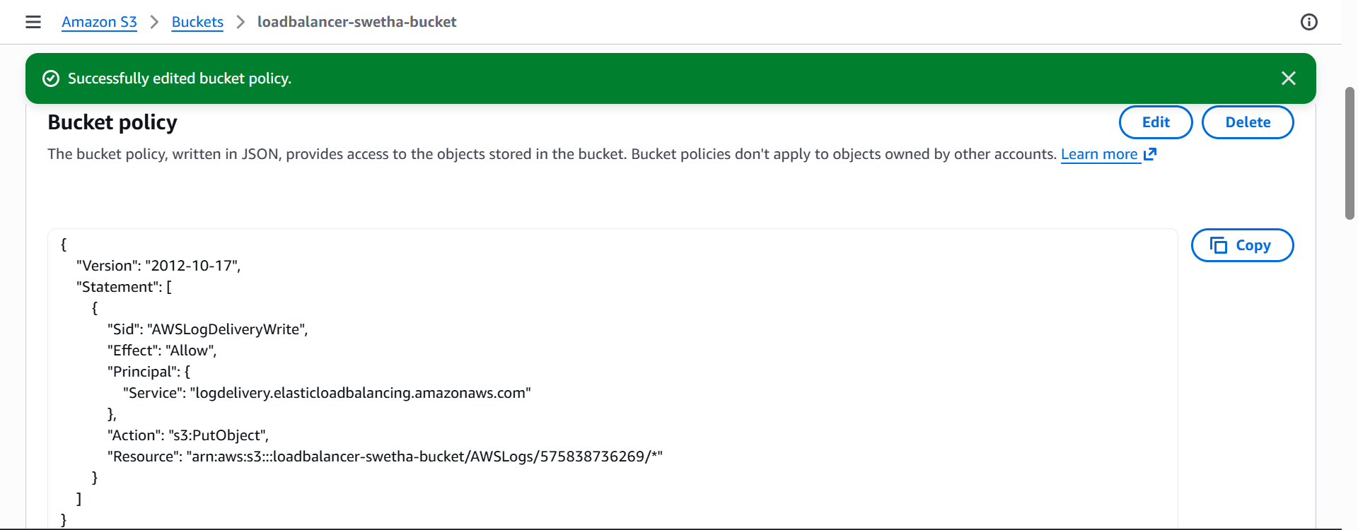
Open the Load Balancer
- Go to EC2 → Load Balancers.
- Select My-ALB.

Step 5: Enable Access Logs
- Click the Attributes tab.
- Click Edit.
Find:
Access logs
Enable it:
- ✅ Enable access logs
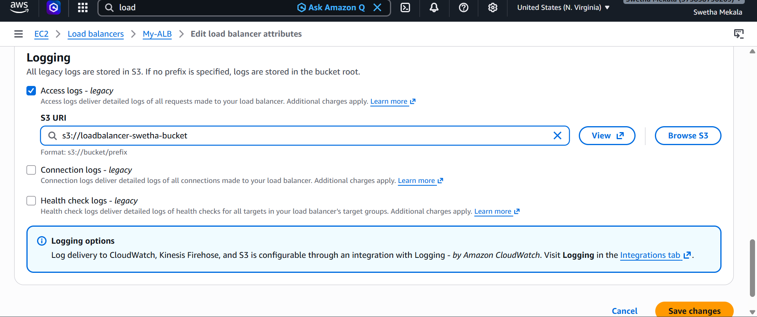
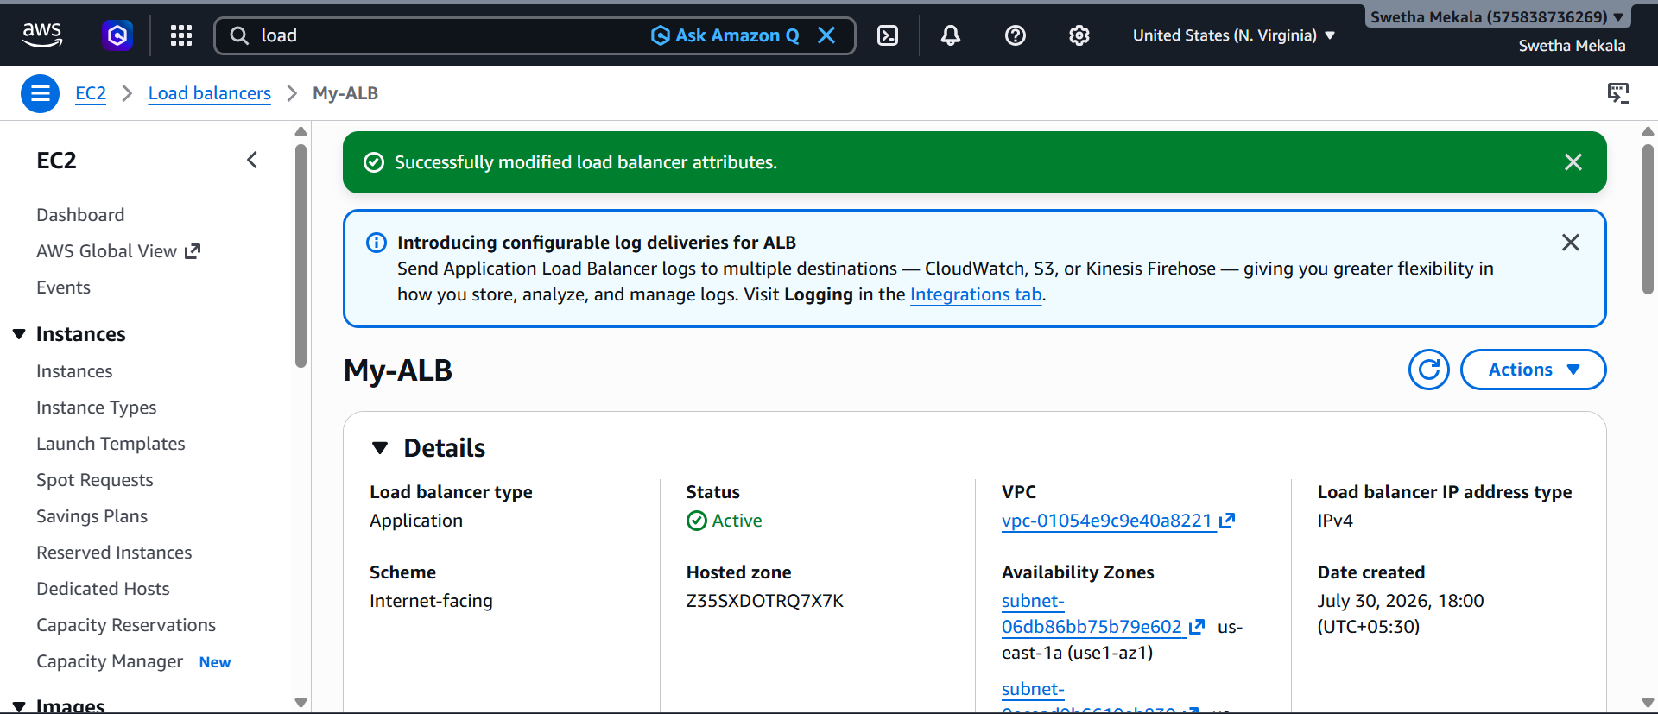
Generate Traffic
Open your ALB DNS in a browser several times:
http://My-ALB-1835912142.us-east-1.elb.amazonaws.com
Refresh the page a few times to create requests.
Verify the Logs
- Go back to S3.
- Open your bucket.
- After a few minutes (sometimes 5–10 minutes), you'll see folders similar to:
AWSLogs/
└── 575838736269/
└── elasticloadbalancing/
└── us-east-1/
└── YYYY/
└── MM/
└── DD/
log-file.gz
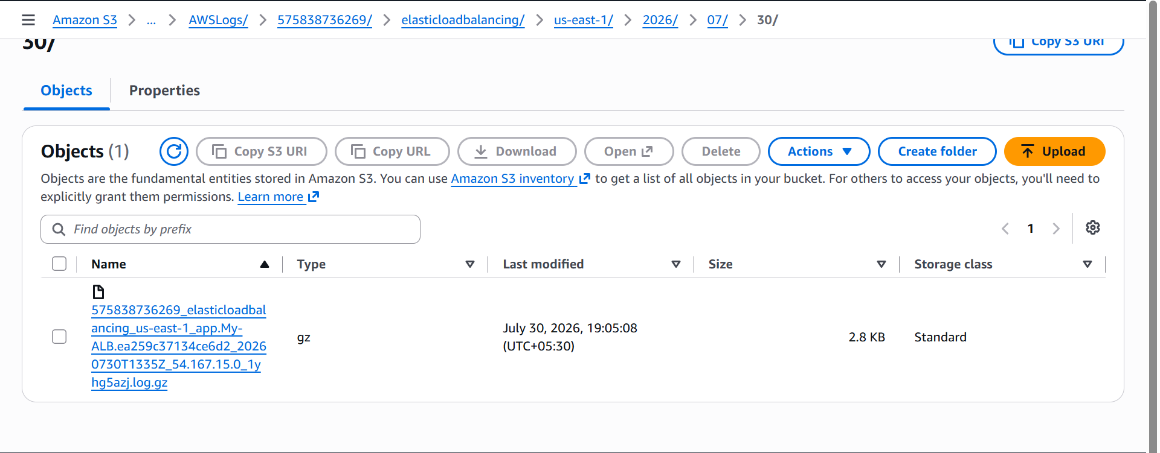
Store the VPC flow logs in a CloudWatch log group.
Select Your VPC
Open the Flow Logs Tab
- With the VPC selected, click the Flow Logs tab.
- Click Create flow log.

Configure the Flow Log
Fill in the following details:
Setting | Value
Name | MyVPCFlowLog (optional)
Filter | All
Maximum aggregation interval | 10 minutes (or 1 minute if your lab specifies it)
Destination | Send to CloudWatch Logs
Destination log group | VPCFlowLogs

Configure Service Access
Under Service access:
- Select Create and use a new service role.
- AWS automatically generates a role name, for example:
VPCFlowLogs-Cloudwatch-1785479820864
Note: You do not need to create an IAM role manually. AWS creates the required role with the necessary permissions.
Log Record Format
Select:
- ✅ AWS Default Format
Leave the following options unchanged:
- Additional metadata → Not selected
- EC2 tag fields → Not selected

Create the Flow Log
Click:
Create Flow Log
AWS will:
- Create the IAM service role.
- Create the CloudWatch Log Group (VPCFlowLogs) if it doesn't already exist.
- Start collecting VPC Flow Logs.

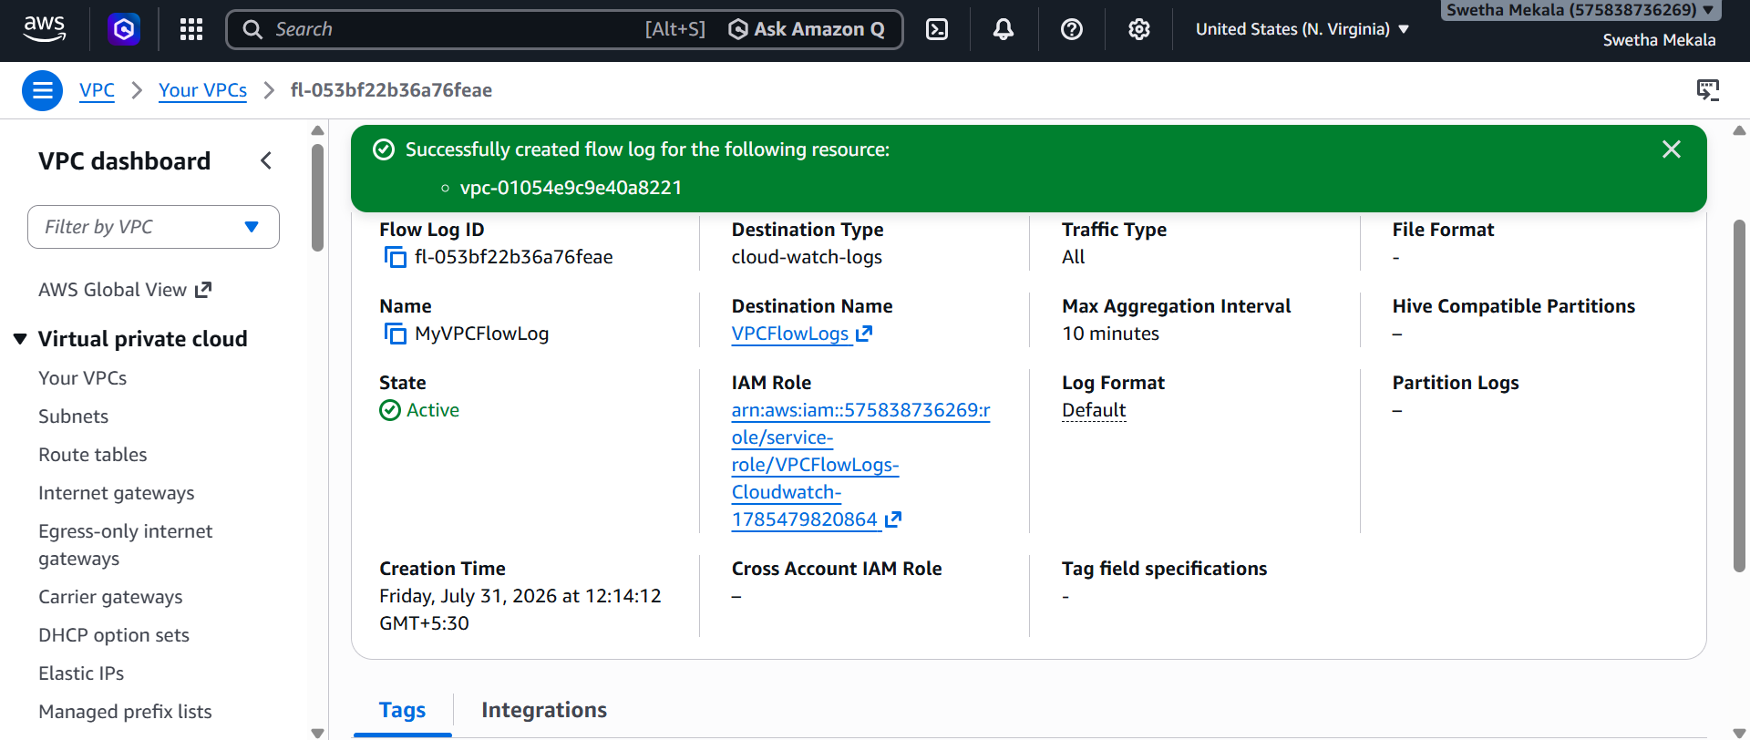
Verify in CloudWatch
- Go to CloudWatch.
- In the left menu, select Logs → Log groups.
- Verify that the following log group exists:
VPCFlowLogs
- Click VPCFlowLogs.

Step 9: Verify Log Streams
Inside the log group, verify that one or more log streams have been created.
For example:
eni-0ac39f33339351a7b-all
nat-1606d9ecf28c2b3b6-all

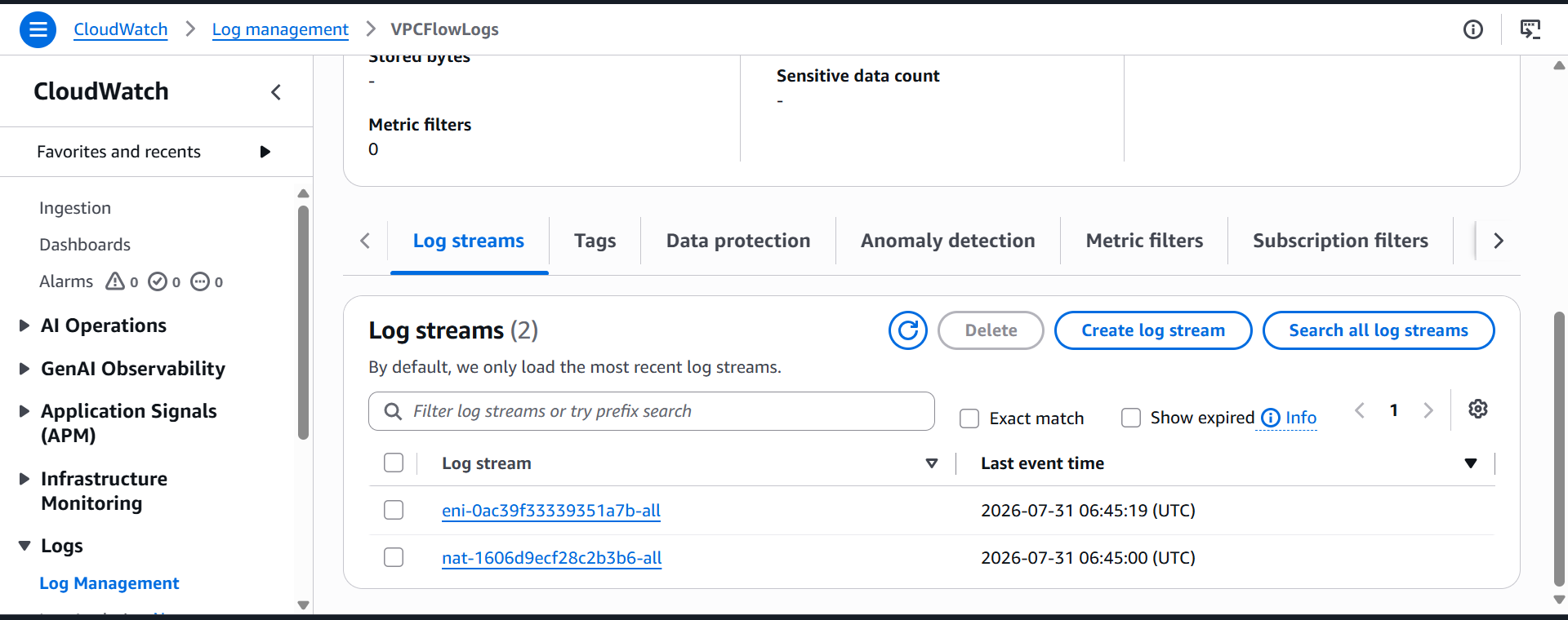
View Log Events (Optional)
Click a log stream to view log entries similar to:
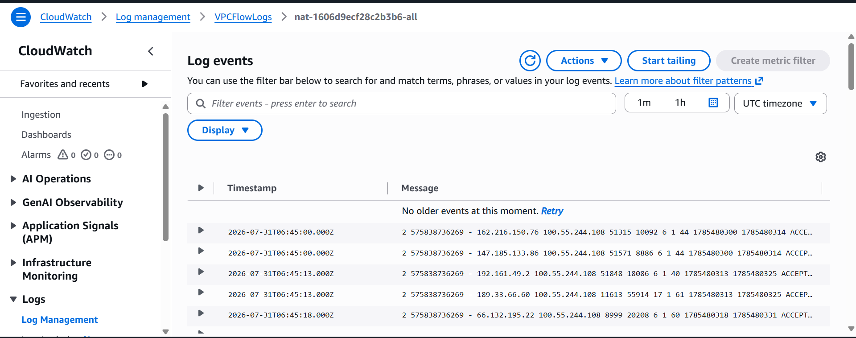
Create monitoring dashboards to monitor CPU utilization and to monitor the Apache service.
Launch or Start the EC2 Instance
Verify Apache is Running
ssh -i <KeyPair.pem> ec2-user@<Public-IP>
sudo systemctl status httpd
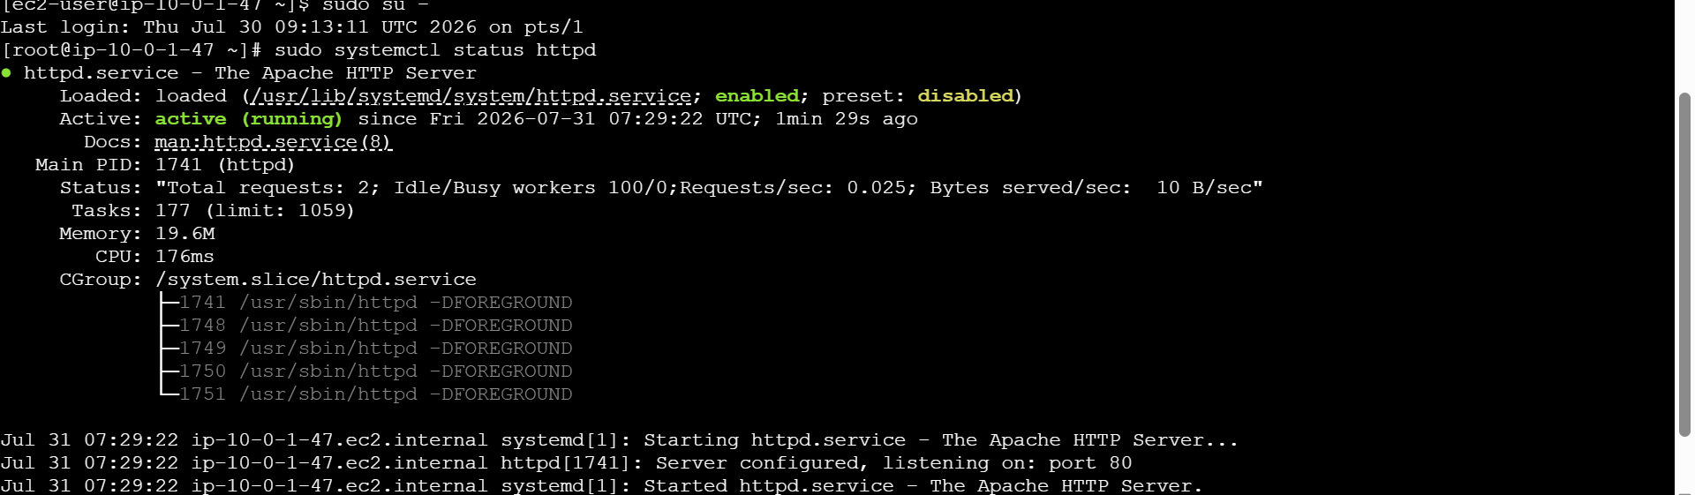
Install the Amazon CloudWatch Agent
- Configure the agent to collect:
  - CPU metrics
  - Memory metrics
  - Apache process (httpd) metrics using procstat
- Start the CloudWatch Agent:
sudo /opt/aws/amazon-cloudwatch-agent/bin/amazon-cloudwatch-agent-ctl \
-a fetch-config \
-m ec2 \
-c file:/opt/aws/amazon-cloudwatch-agent/etc/amazon-cloudwatch-agent.json \
-s
- Verify the agent is running:
sudo systemctl status amazon-cloudwatch-agent
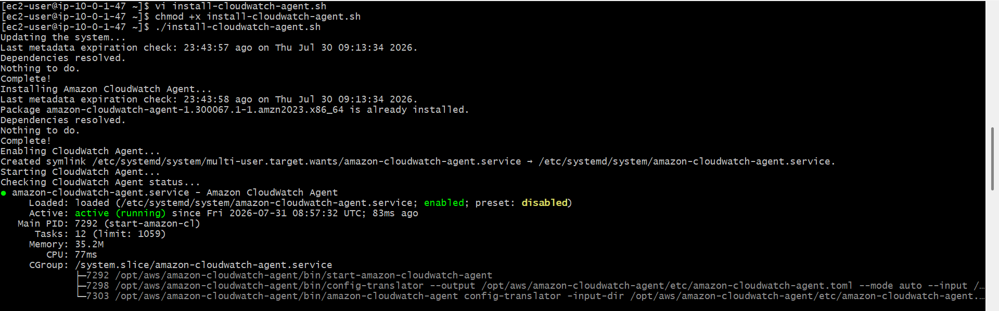
Attach an IAM Role
- Open the EC2 Console.
- Select the EC2 instance.
- Choose Actions → Security → Modify IAM role.
- Attach the IAM role with the CloudWatchAgentServerPolicy permission.
- Save the changes.
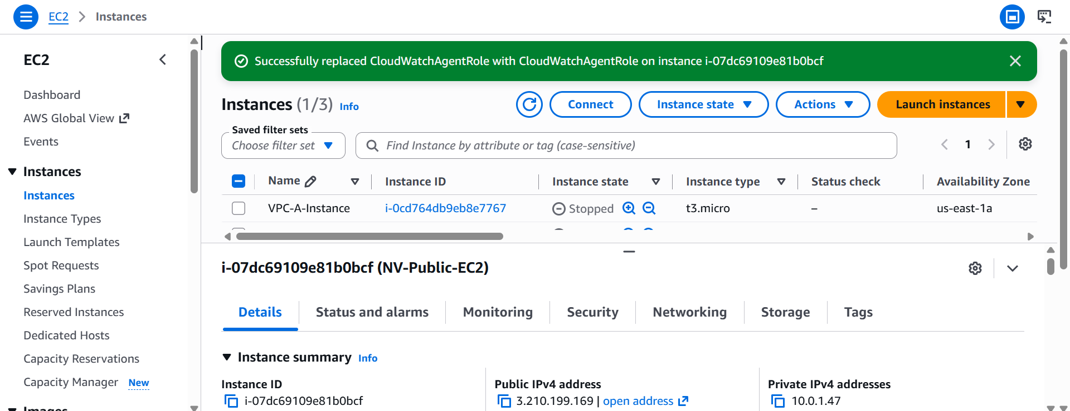
Verify CloudWatch Metrics
- Open CloudWatch.
- Select Metrics → Classic metrics.
- Verify that:
  - EC2 namespace contains the CPUUtilization metric.
  - CWAgent namespace contains the procstat_lookup_pid_count metric.
Create a CloudWatch Dashboard
- Open CloudWatch.
- Choose Dashboards.
- Click Create dashboard.
- Enter the dashboard name:
MonitoringDashboard
- Click Create dashboard.
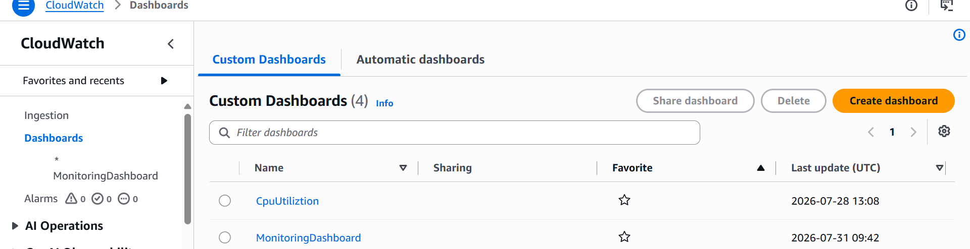

Add the Apache Service Widget
- Click Add widget.
- Select Number or Line.
- Choose CWAgent.
- Select:
InstanceId, pattern, pid_finder
- Select the metric:
procstat_lookup_pid_count
- Click Create widget.
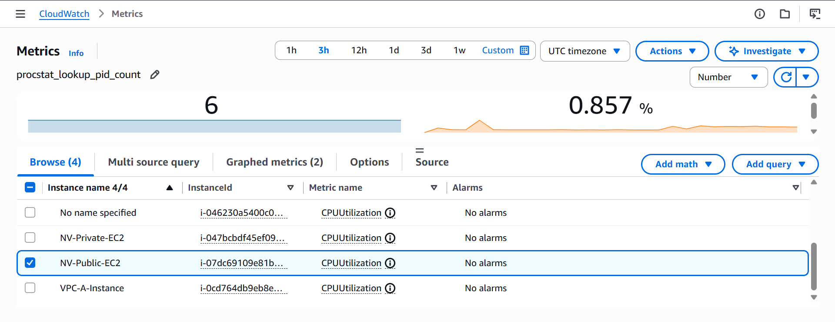
Save the Dashboard
- Click Save dashboard.
- Verify the dashboard displays:
  - CPUUtilization
  - procstat_lookup_pid_count
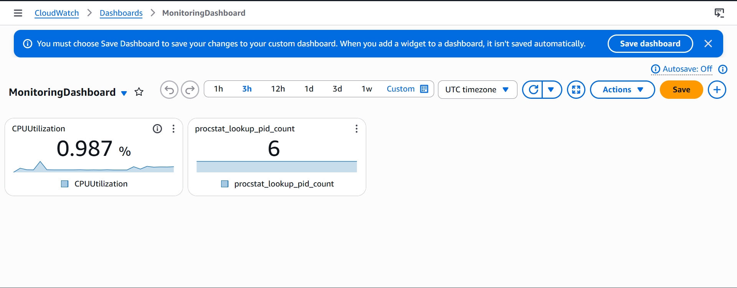
If CPU utilization is more than 70%, then it should trigger auto scaling and launch new instance.
Create an AMI from the Existing EC2 Instance
The Auto Scaling Group launches new instances from an AMI.
- Open the EC2 Console.
- Select your running EC2 instance.
- Click Actions → Image and templates → Create image.
- Enter:
  - Image name: Apache-AMI
  - Image description: AMI for Auto Scaling
- Click Create image.
- Wait until the AMI status becomes Available.
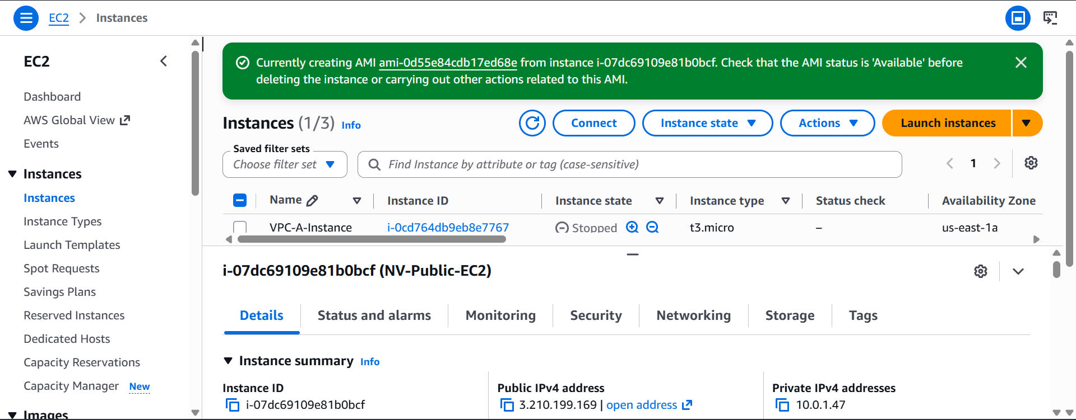
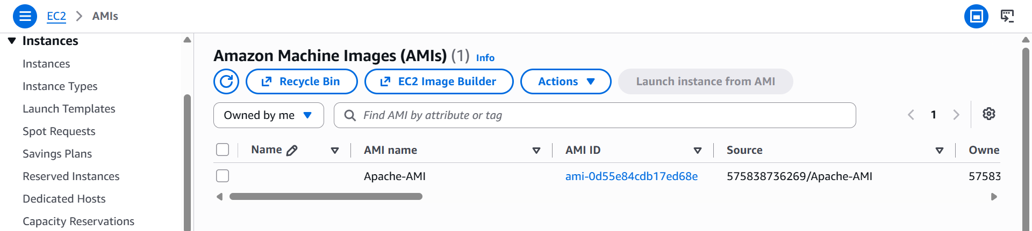
Create a Launch Template
- In the EC2 Console, click Launch Templates.
- Click Create launch template.
- Enter:
Field | Value
Launch Template Name | ApacheLaunchTemplate
AMI | Apache-AMI
Instance Type | t2.micro
Key Pair | Your Key Pair
Security Group | Your Security Group
Click Create launch template

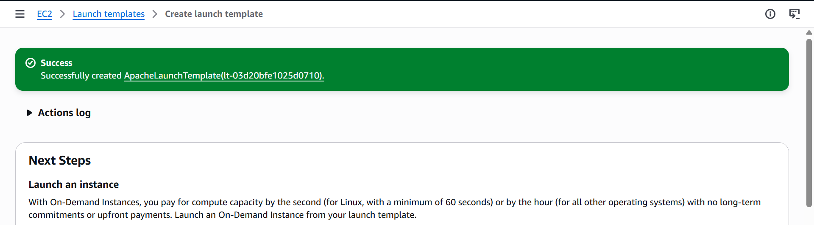

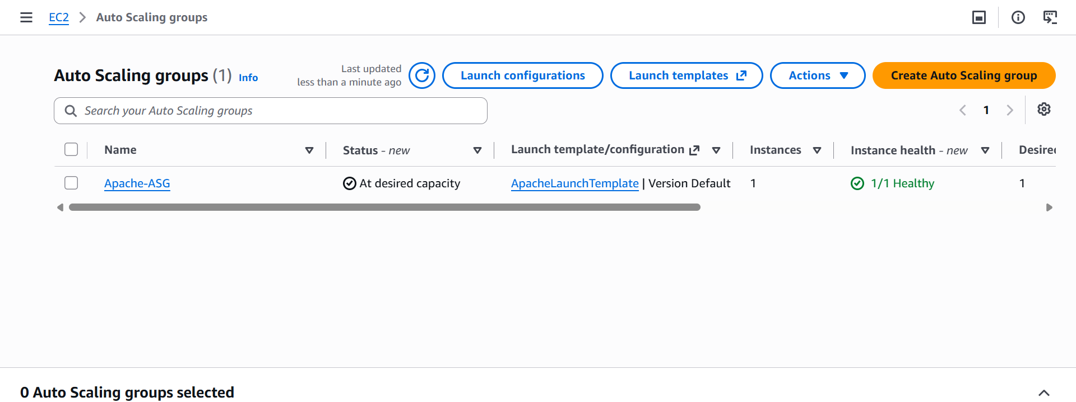
Dynamic policy created
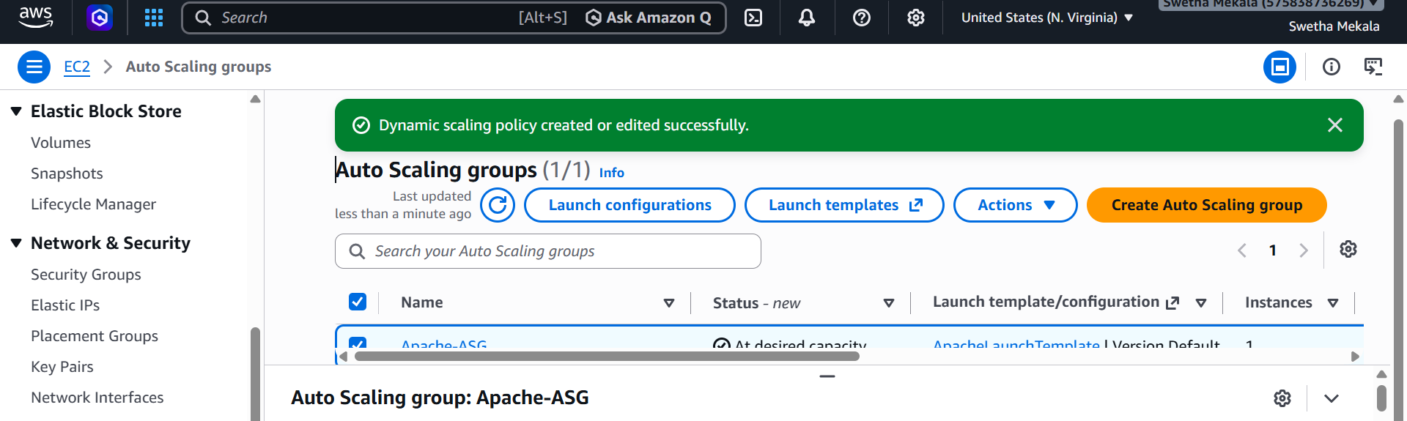
test Auto Scaling
- SSH into your EC2 instance.
- Run:
stress --cpu 2 --timeout 600
- Wait about 2–3 minutes (because Detailed Monitoring is now enabled).
- Check:
  - CloudWatch → Metrics → EC2 → CPUUtilization
  - EC2 → Auto Scaling Groups → Activity
If CPU stays above 70%, you should see the ASG launch a second instance.
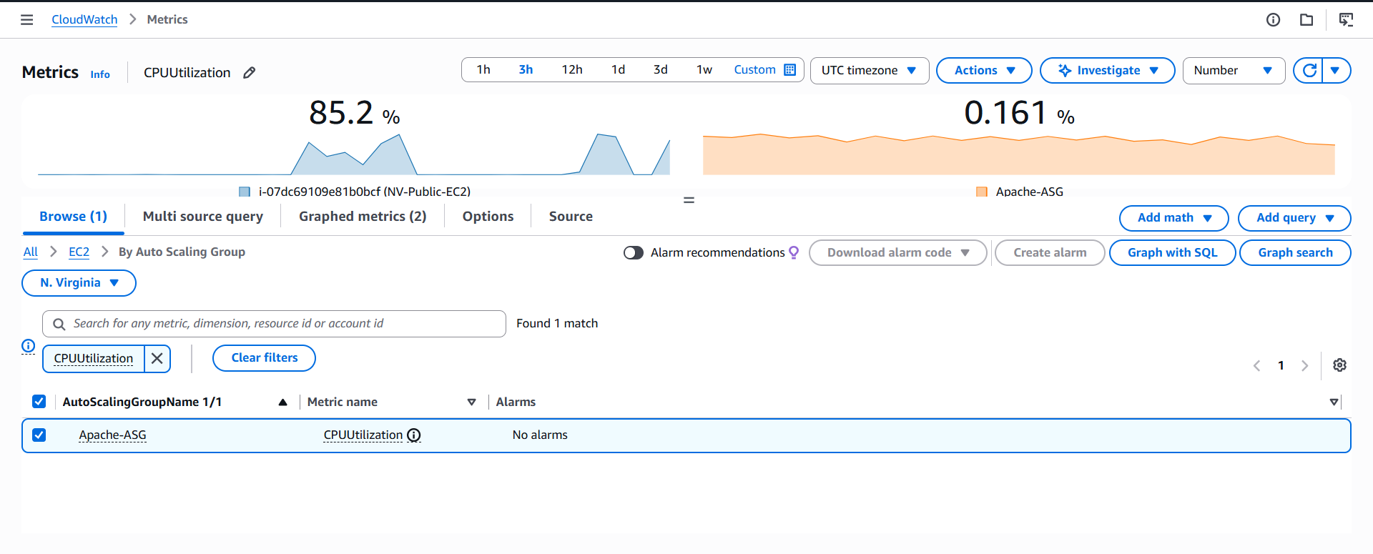Open Auto Scaling Groups
Select Apache-ASG.
Edit the Auto Scaling Group
- Click Edit (or Actions → Edit, depending on the console view).

Step 3: Change the Desired Capacity
Find the Capacity section and change the values to:
Minimum capacity : 1
Desired capacity : 2
Maximum capacity : 2
Only change Desired capacity from 1 to 2.
Click Update or Save changes.

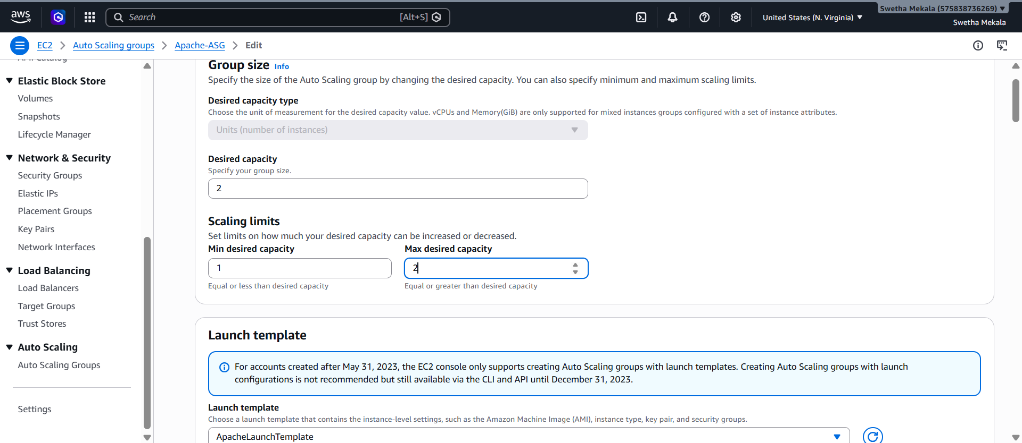
Check the Activity Tab
Go to:
EC2 → Auto Scaling Groups → Apache-ASG → Activity
You should see one of these:
If everything is working
Launching a new EC2 instance
A second EC2 instance will appear.

